**Exercise 1: Implementing the Singleton Pattern**

**Scenario:**

You need to ensure that a logging utility class in your application has only one instance throughout the application lifecycle to ensure consistent logging.

Logger

public class Logger {

private static Logger *singleInstance*;

private Logger() {

System.***out***.println("Logger initialized.");

}

public static Logger getInstance() {

if (*singleInstance* == null) {

*singleInstance* = new Logger();

}

return *singleInstance*;

}

public void log(String message) {

System.***out***.println("Log: " + message);

}

}

TestLogger

public class TestLogger {

public static void main(String[] args) {

Logger logger1 = Logger.*getInstance*();

Logger logger2 = Logger.*getInstance*();

logger1.log("This is the first log message.");

logger2.log("This is the second log message.");

if (logger1 == logger2) {

System.***out***.println("Both logger1 and logger2 are the same instance.");

} else {

System.***out***.println("Different instances exist! Singleton failed.");

}

}

}

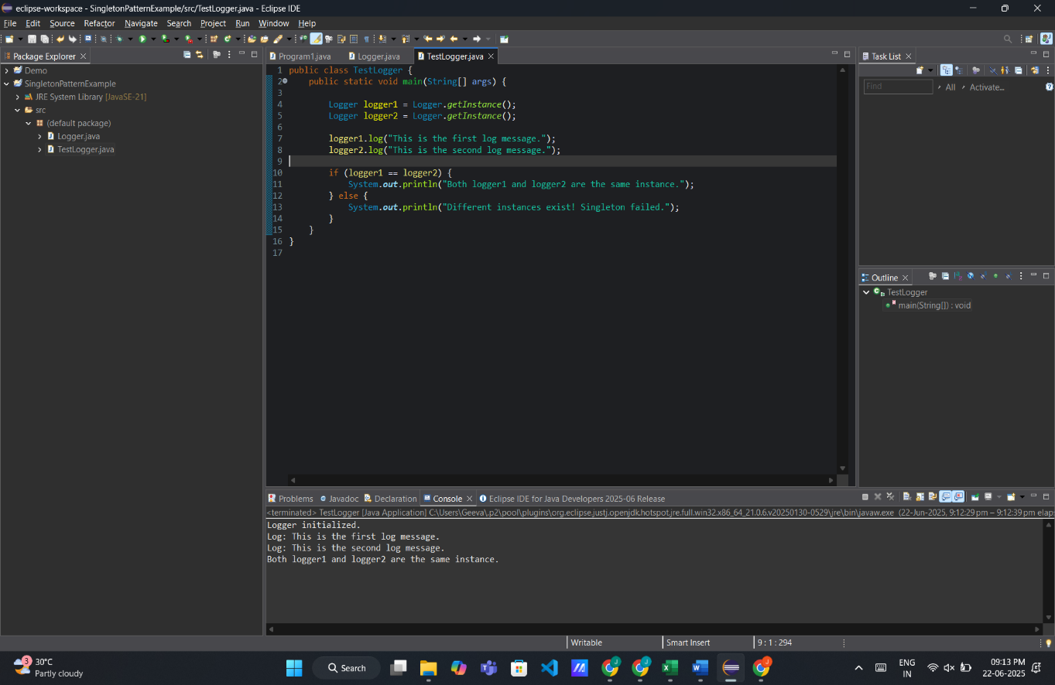

**Exercise 2: Implementing the Factory Method Pattern**

**Scenario:**

You are developing a document management system that needs to create different types of documents (e.g., Word, PDF, Excel). Use the Factory Method Pattern to achieve this.

**Document.java**

public interface Document {

void open();

}

**WordDocument.java**

public class WordDocument implements Document {

public void open() {

System.out.println("Opening Word document...");

}

}

**PdfDocument.java**

public class PdfDocument implements Document {

public void open() {

System.out.println("Opening PDF document...");

}

}

ExcelDocumnet.java

public class ExcelDocument implements Document {

public void open() {

System.out.println("Opening Excel document...");

}

}

**DocumentFactory.java**

public abstract class DocumentFactory {

public abstract Document createDocument();

}

**WordDocumentFactory.java**

public class WordDocumentFactory extends DocumentFactory {

public Document createDocument() {

return new WordDocument();

}

}

**PdfDocumentFactory.java**

public class PdfDocumentFactory extends DocumentFactory {

public Document createDocument() {

return new PdfDocument();

}

}

**ExcelDocumentFactory.java**

public class ExcelDocumentFactory extends DocumentFactory {

public Document createDocument() {

return new ExcelDocument();

}

}

**TestFactoryMethod.java**

public class TestFactoryMethod {

public static void main(String[] args) {

DocumentFactory wordFactory = new WordDocumentFactory();

Document wordDoc = wordFactory.createDocument();

wordDoc.open();

DocumentFactory pdfFactory = new PdfDocumentFactory();

Document pdfDoc = pdfFactory.createDocument();

pdfDoc.open();

DocumentFactory excelFactory = new ExcelDocumentFactory();

Document excelDoc = excelFactory.createDocument();

excelDoc.open();

}

}

